KENSINGTON POLICE PROTECTION AND COMMUNITY SERVICES DISTRICT

Board of Directors Strategic Planning Session

Thursday, January 27, 2022
Via Teleconference
7:00 p.m.

President Hacaj called the Special Meeting to order at 8:35 a.m.

Director Chris Deppe, Vice-President Mike Logan, Director Eileen Nottoli, Director Rachelle Sherris-Watt and President Sylvia Hacaj were present.

Staff present included Interim General Manager Richard J. Benson, General Counsel Ann Danforth, and Clerk of the Board Lynelle M. Lewis.

Meeting facilitators included: Martin Rauch and Amanda Greene of Martin Rauch Communications.

Public Comments
None.

Discussion of District Strategic Plan
The Board of Directors participated in a strategic planning workshop focusing on issues of concern to the District and establishing goals and objectives for the District. Areas of focus included, without limitation:

- Areas of responsibility
- Projects currently underway
- Future projects
- Resources needed to achieve District goals
- General Manager recruitment; senior staff stability

No formal action was taken by the Board.

Adjournment

President Hacaj adjourned the meeting at 3:32 p.m.

The next regular meeting is scheduled for Thursday, February 10, 2022.

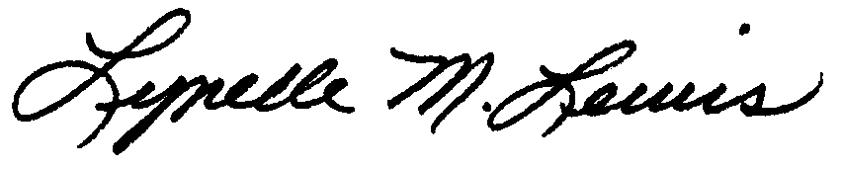
_____________________________________
Lynelle M. Lewis, District Clerk of the Board

