PICNIC RESERVATION FORM
59 Arlington Ave.,
Kensington, CA 94707
Phone: 510-526-4141 x 4

Each reservation is for a full day from sunrise to sunset (8 AM - 7 PM), and each site will be reserved once daily. All sites required a refundable cleaning deposit of $30, which will be returned ten days after the event. The deposit amount will be lost if any damages or trash is left behind. Additional amenities such as playgrounds, basketball courts, and more are available in various areas but are not included in picnic reservations, and will remain open to the public during park open hours. The restrooms are located near the Windsor Ave entrance to the park. Please stop by the District Office at Public Safety Building at 10940 San Pablo Ave, Building B, El Cerrito, CA 94530, for more information about the rental process. Check or cash only. Liability insurance not required for sites.

FIRST & LAST NAME: _________________________________________________
HOME ADDRESS: ____________________________________________________
PHONE NUMBER: ____________________________________________________
EMAIL ADDRESS: ____________________________________________________
SITE NAME: ________________________________________________________
ALTERNATE SITE: ____________________________________________________
TYPE OF EVENT: _____________________________________________________
RESERVATION DATE: _________________________________________________

I hereby apply to the Kensington Police Protection & Community Services District for permission to use the facilities/park grounds at 59 Arlington Ave. I have read, agree to, and will enforce the procedures, policies, and regulations listed on this application; a representative of the Services District has approved it in writing.

Signature: ______________________________________ Date: ___________________

CHECK ONE
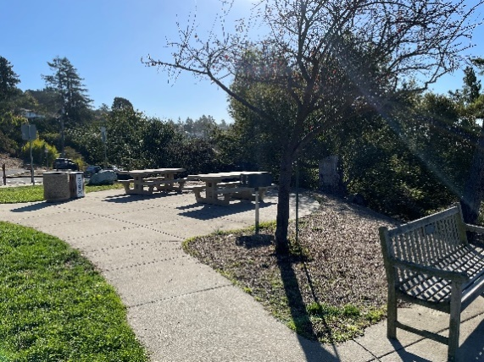
- Site 1: Windsor Ave
• Max capacity of 20 guests
• 2 Concrete tables
• 2 BBQ Grill

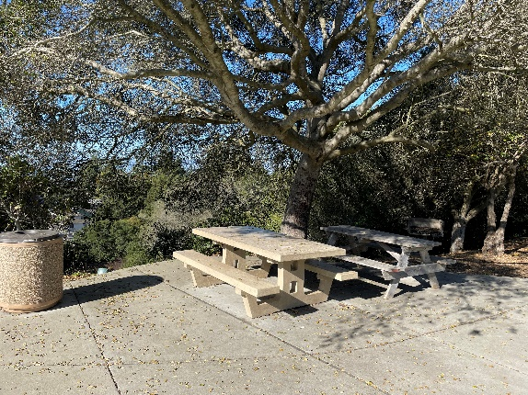
- Site 2: Basketball Court
• Max capacity of 20 guests
• 2 tables
• 1 BBQ Grill

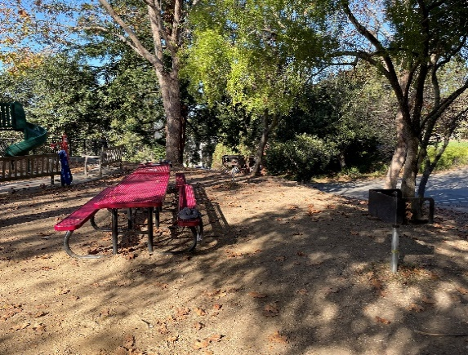
- Site 3: Tot Lot
• Max capacity of 20 guests
• 2 Red tables
• 2 BBQ Grill

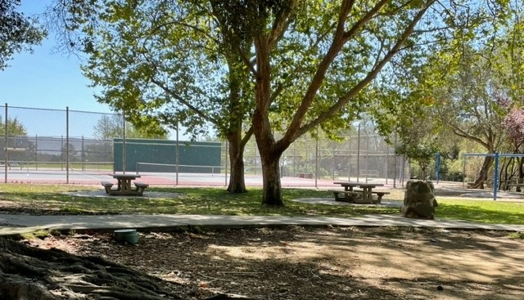
- Site 4: Tennis Court
• Max capacity of 20 guests
• 2 Concrete tables
• No BBQ Grill

